Introduction
GA4 or Google Analytics 4 is a new property feature of Google Analytics, developed for future of the measurement. This property of Google Analytics
- Collects both app and website data to understand the customer journey in a better way
- It includes behavioral conversion modeling and cookie less measurement which ensures privacy controls
- Instead of session-based, GA4 uses event-based data
- Predictive capabilities of GA4 offer guidance without any complex models
Google Analytics had Universal Analytics property which will no longer process any data from July 1, 2023. Even though you will be able to see your reports for a certain period after July 1, it will no longer process your new data. Therefore, it is mandatory for everyone using google analytics to move to GA4 before July 1, 2023.

Setup of GA4
There can be two scenarios for setting up GA4.
- Those who already have a Universal Analytics property and want to directly migrate it to an equivalent GA4 property.
- Those who wants to set up a new GA4 property for their business.

For the first case scenario the steps will be
- Open Google Analytics.
- In case you already have a Universal Analytics Property and don’t want to create a new GA4 property for your website, instead want to setup a GA4 for property equivalent to the same Universal Analytics, then select the ‘Admin Settings’ as before and go to the page as showing in the picture below. Then click on the GA4 Setup Assistant.
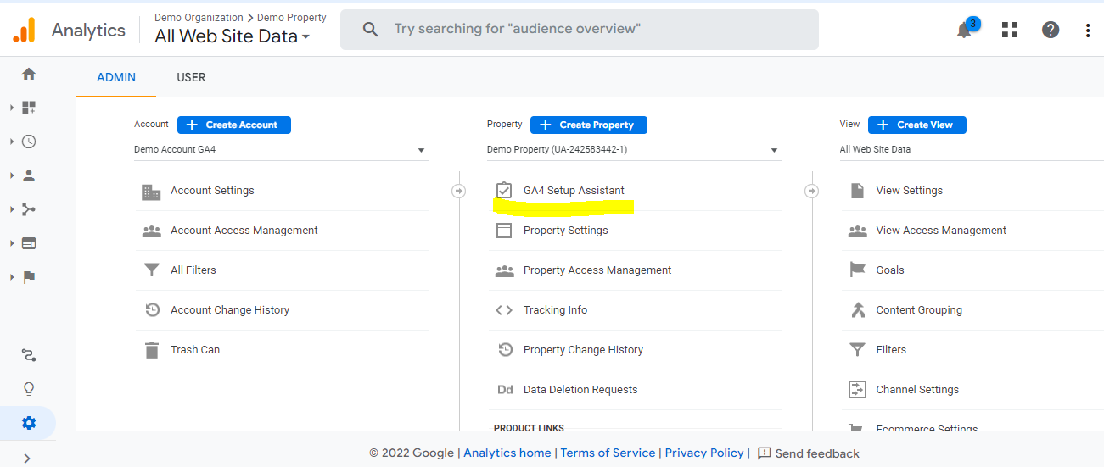
Figure 1
- You will be redirected to this page. Click on the ‘Get started’ button
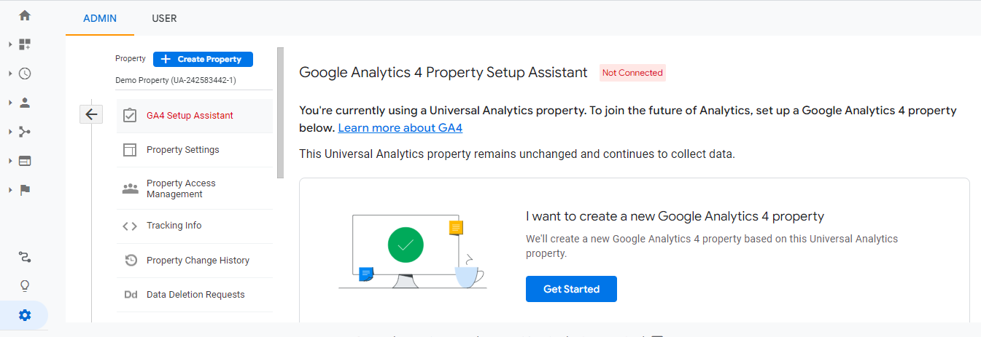
Figure 2
- In this page, click on the ‘Create Property’ button at the bottom right corner
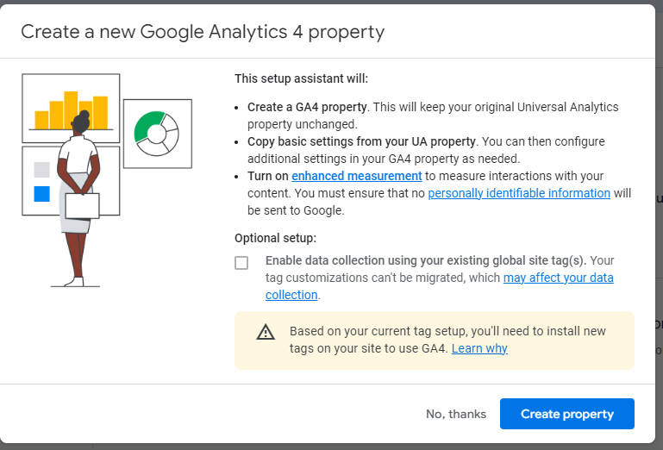
Figure 3
- The window shown in the picture below will open. Click on the ‘Go to your GA4 property’ button.
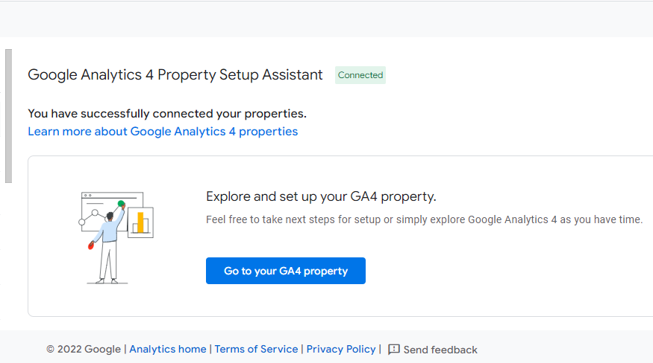
Figure 4
- This setup assistant page will open. It means a property for GA4 has been created and the name of the GA4 property includes your previous UA property name and add a ‘-GA4’ in the end (Ex. ‘Previious_UniversalAnalytics_Name-GA4’). You can go back to your home page
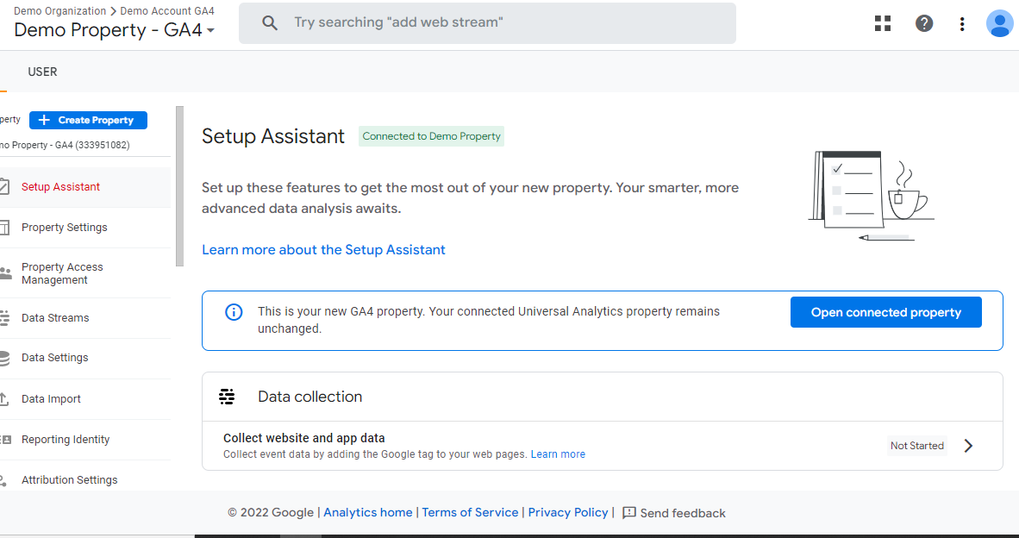
Figure 5
- In case you want to find the Measurement ID for your new GA4 property, go to the Admin Settings page of your GA4 property and then go to the Property Column. In that column you will find the ‘Data Stream’ option.
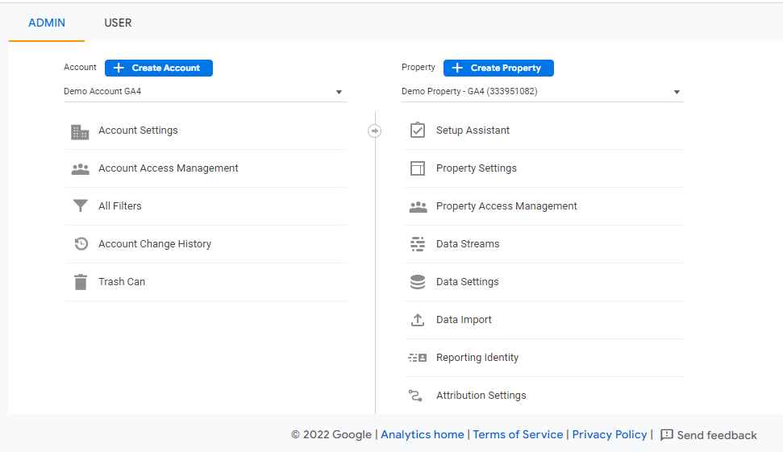
Figure 6
- Click on your GA4 property Data Stream.
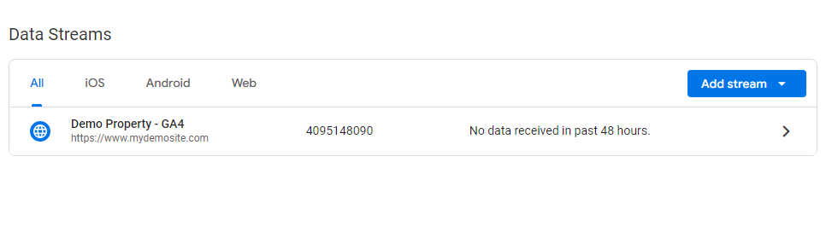
Figure 7
- Here is your GA4 property Measurement ID as shown in the highlighted section of the picture below. You can copy it.
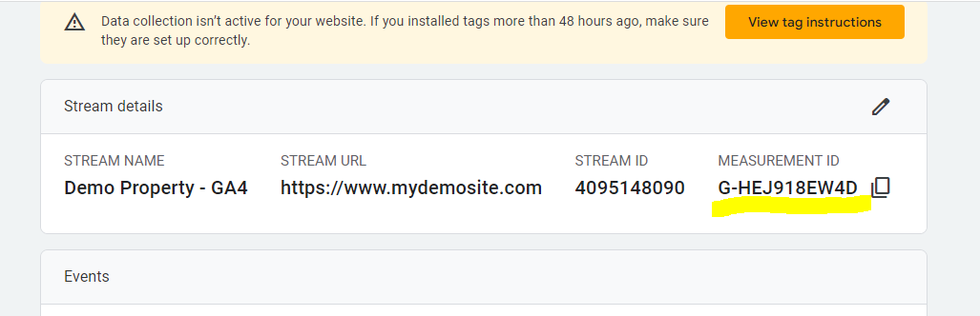
Figure 8

For the second case scenario the steps will be:
- Open Google Analytics.
- Go to the highlighted Admin Section and you will get to see this page as shown in the picture below. In this page you must click on the ‘Create Property’ button which is highlighted in the picture.
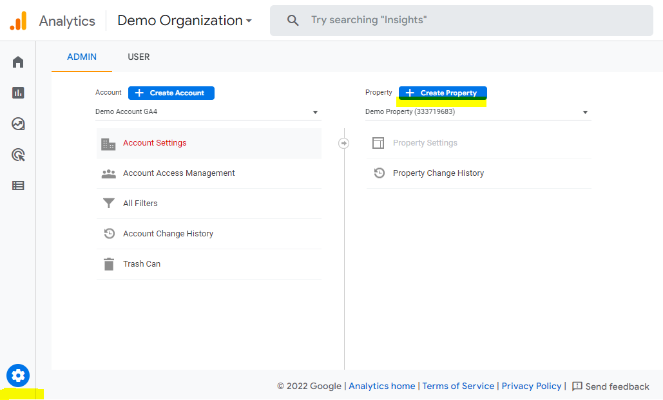
Figure 9
- A window as shown in the picture below will open where you must put all the necessary details regarding your website and click the ‘Next” button at the bottom left corner of the screen.
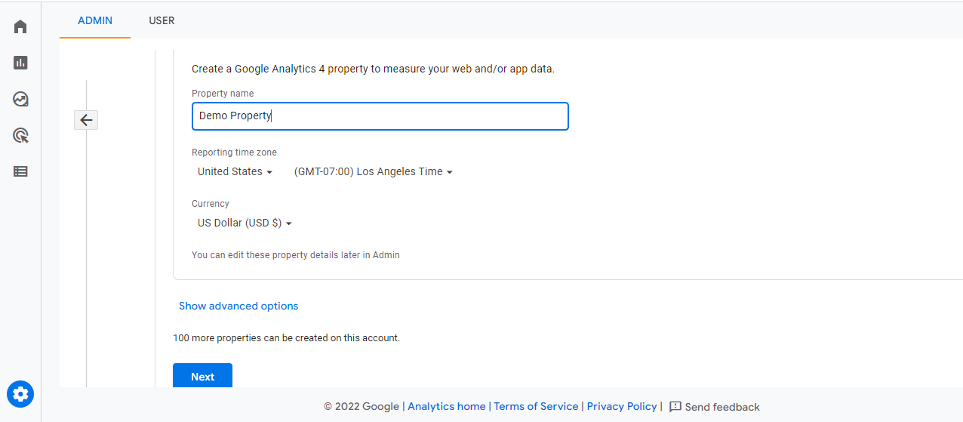
Figure 10
- This window will open after clicking the ‘Next’ button where you can select all the appropriate option based on your business and then click on the ‘Create’ Button at the bottom.
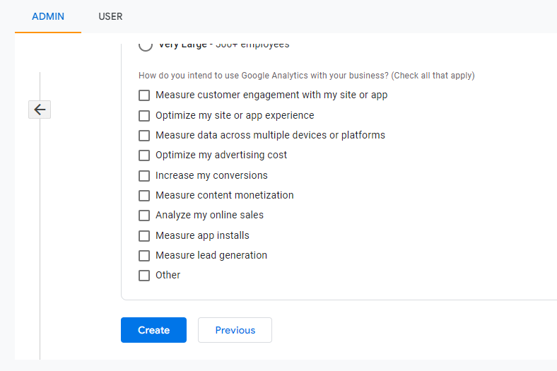
Figure 11
- After clicking the Create button you will be redirected to this window as shown in the picture below. Choose the Web option.
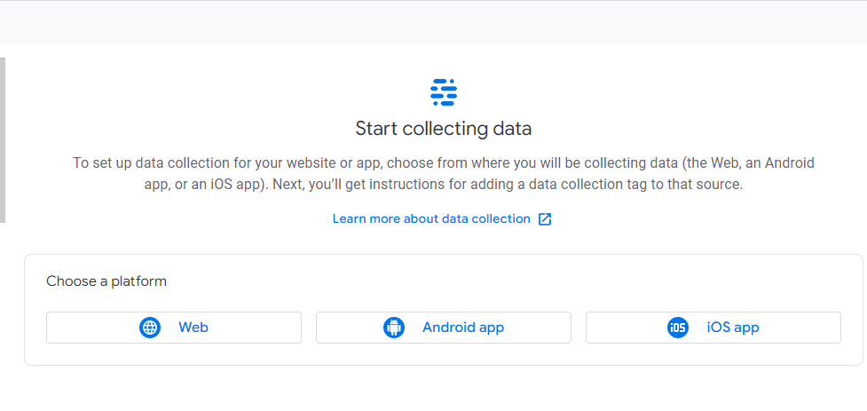
Figure 12
- You will be redirected to this page as showing in the picture below. Put your website URL and a stream name (It can be the name of your website or business). then click on the ‘Create Stream’ Button below.
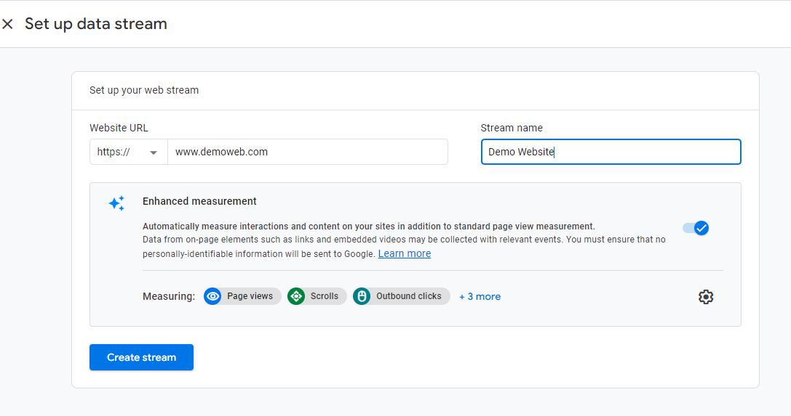
Figure 13
- This web stream details page will open with your Measurement ID, which is the most important key for GA4 setup. You can close the window by clicking on the ‘X’ on the top left corner of the screen.
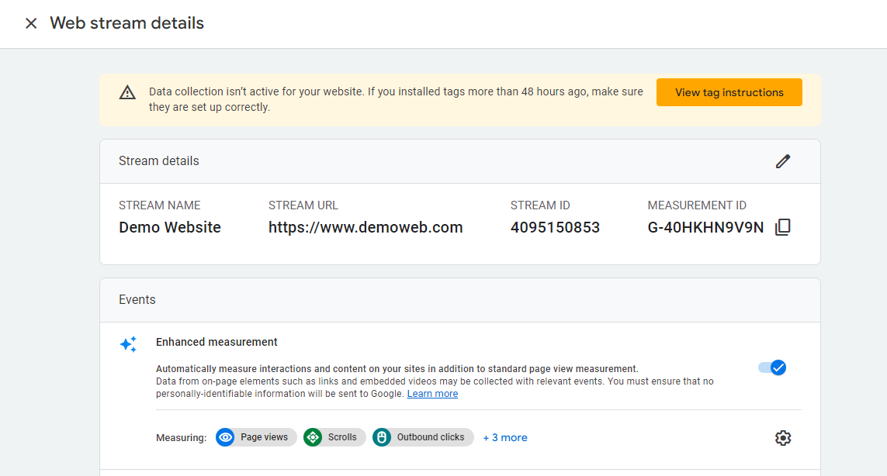
Figure 14

Google Analytics setup in CarChat24 website
Once you are done creating your GA4 property in Google Analytics, you have to setup your CarChat24 account to receive event data directly to google analytics account
- Go to your carchat24 website and go to the web integration page. There you can get the ‘Google Analytics Settings’ button as highlighted in the picture below. Click on that
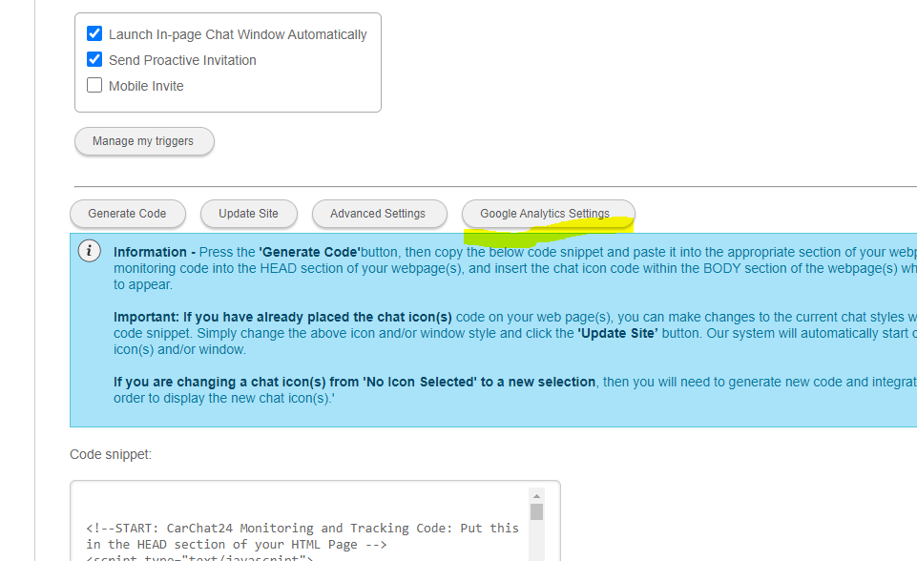
Figure 15
- A popup window like the picture below will open. There check the ‘Enable Google Analytics’ checkbox
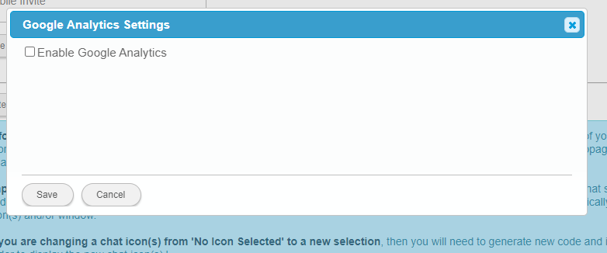
Figure 16
- As shown in the below picture, put your Measurement ID starting with ‘G’ in the highlighted box. Select all the necessary options as per your preferences and customize it if needed. Then click on the ‘Save’ button below. Your GA4 setup is completed now
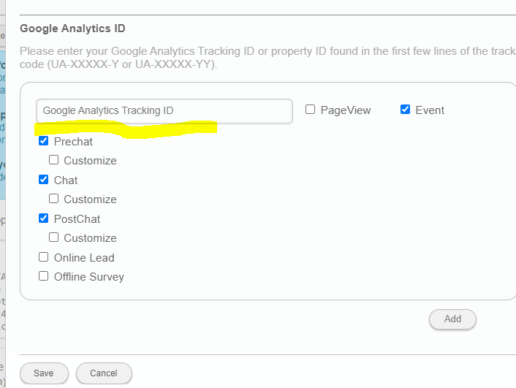
Figure 17

Conclusion
That concludes the journey of GA4 setup. Thank you for taking your time out and going through this document.

