Chat Switch
This feature gives power to visitor to change its chat mode, without getting disconnected. It will be a smooth transition of the chat from one mode to
another chat mode.
Architecture of this feature will be designed in such a way that; it can accommodate all types of feasible chat switch “anything to anything mode switch” and can handle “multiple chat switch in a chat”.
Development planning for this feature (Phase wise):
PH-1. WEB TO SMS - CHAT SWITCH
A visitor can move to SMS chat smoothly from an ongoing web chat.
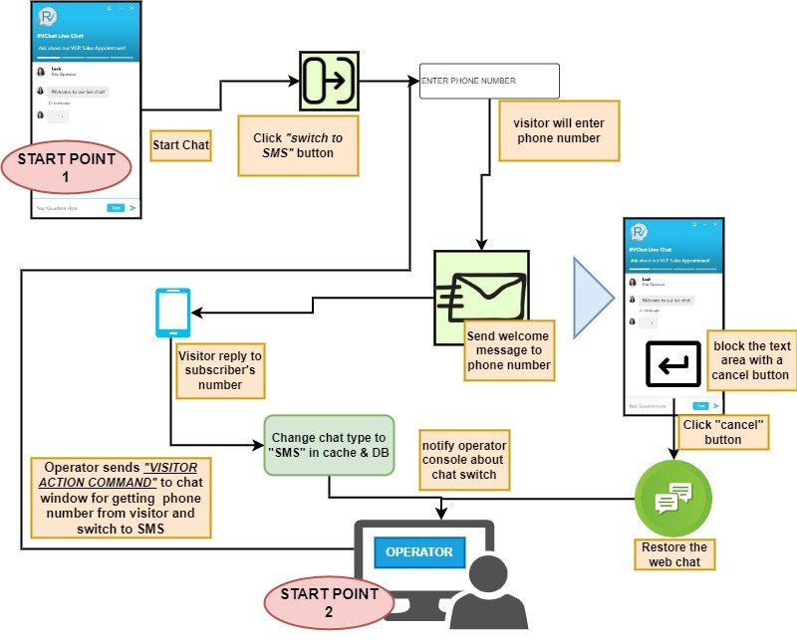

1. After the start of the web chat, a “chat switch” button will be placed in the chat window to change its chat mode.
2. On click of the “chat switch” button, an area will open to take the visitors phone number.
3. On successful sending of the text message to visitor phone number, a confirmation message will be displayed in the chat window with a “Chat Switch Revert” button for 10s.
4. If visitor clicks the “Chat switch revert” button in the chat window, then chat will be restored in the web chat mode.
5. After that chat will continue from visitor phone, without disrupting the ongoing chat in operator side.
6. Operator can also assist visitor to switch the chat mode via “VISITOR ACTION COMMAND”

PH-2A. WEB TO SMS - RECONNECT SWITCH
Operator can now reconnect a web chat, if web chat contains the phone number of the visitor which was collected in the lead from the previous chat, anytime from our console.

PH-2B. OFFLINE TO SMS - RECONNECT SWITCH
Operator can now reconnect an offline lead, if offline lead contains the phone number of the visitor from the operator console.

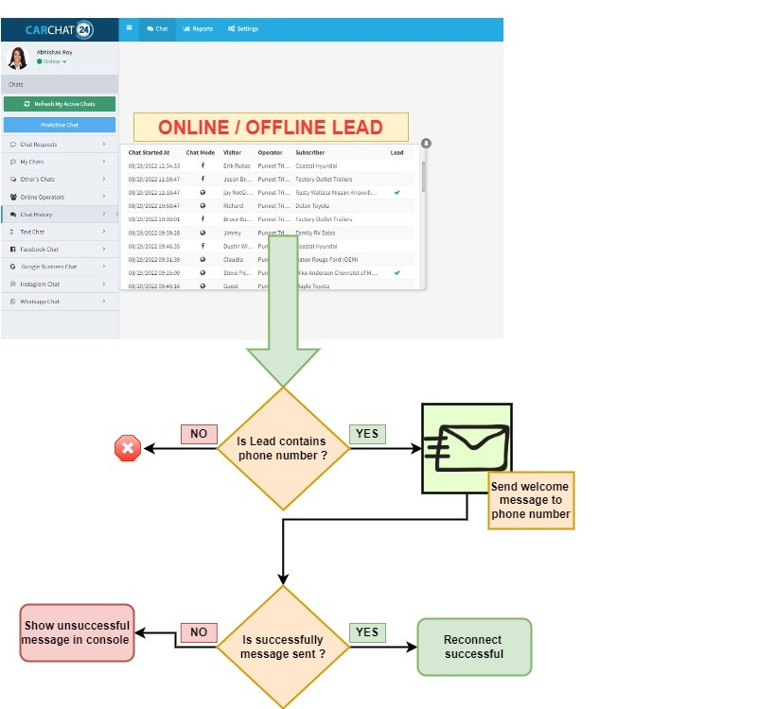

PH-3. WEB TO WHATSAPP - CHAT SWITCH
A visitor can move to WhatsApp chat smoothly from an ongoing web chat.

